
HOME | ABOUT THE FIRM | OUR LAWYERS | OUR PRACTICE AREAS | CONTACT US

Landing Page Slides:


(BUTTON) “more about us”
Function: scrolls down to about the firm section of landing page

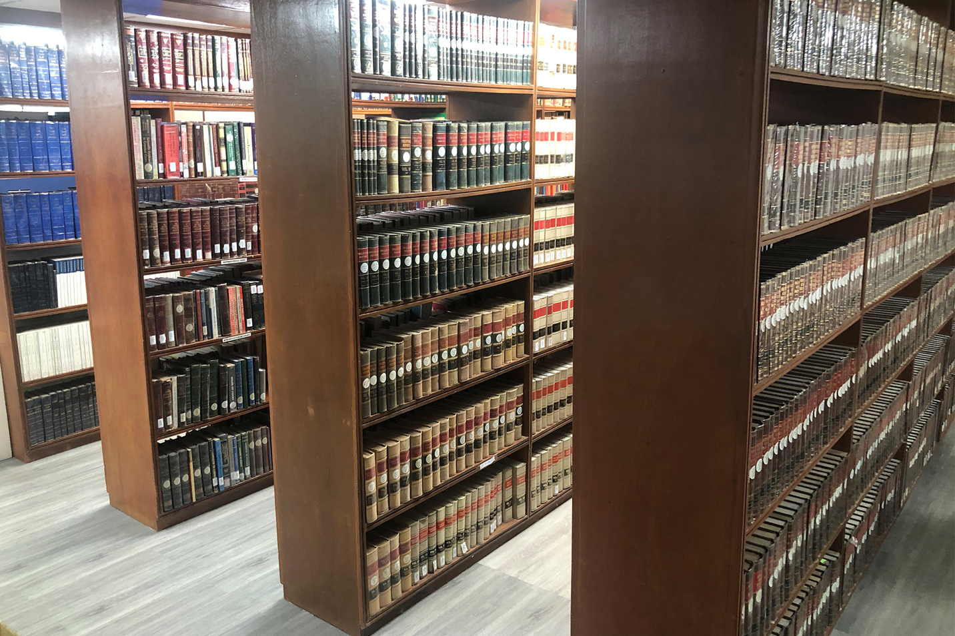
(BUTTON) “our lawyers”
Function: scrolls down to about the firm

(static text) All our clients make the right choices!

Get in touch with us today we look forward hearing from you

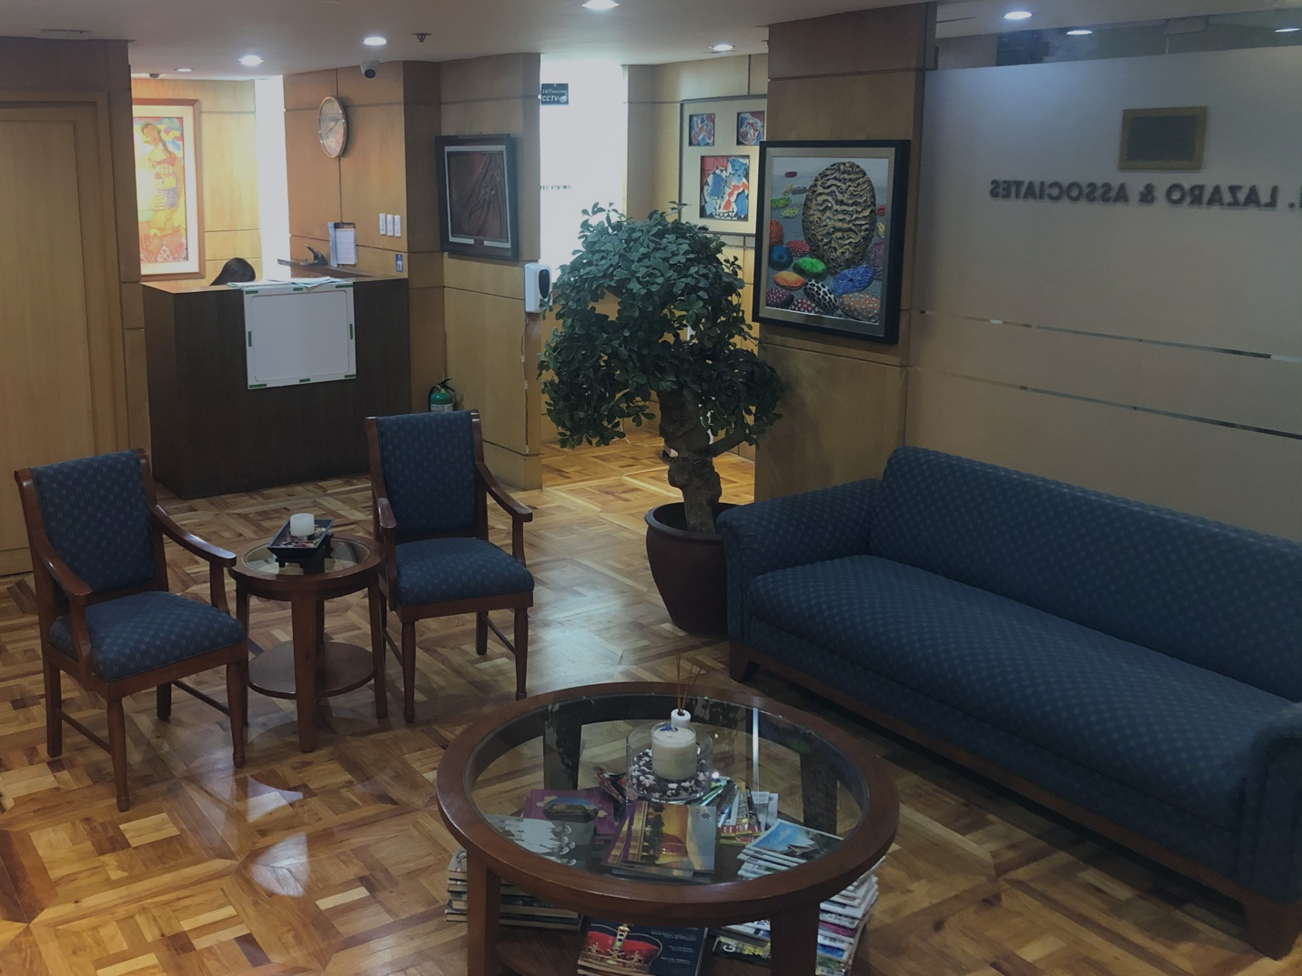

(static text) All our clients make the right choices!

Get in touch with us today we look forward hearing from you

(BUTTON) “our practice areas”
Function: scrolls down to about the firm

About the Firm:

A vision to create a true corporate meritocracy dedicated to excellence in the practice of law. The sole measures of our success are concrete results and client satisfaction.

"An innovative law firm by building long-term relationships with clients based on reciprocity, trust and highest standards of professional ethics. By adopting new models for the delivery of legal services, we strive to redefine the role that a law firm plays in an emerging regional market, in order to produce truly exceptional results for our clients."

Our Lawyers:

Our lawyers and other professionals are recognized for their innovative approach to solving complex legal problems and exceptional service, high ethical standards, attention to detail, and responsiveness.

MM Lazaro Esq.

Atty. Lazaro is the Founder and Senior Partner of M.M. Lazaro and Associates and is one of the incorporators of TDF. He previously served the government in the following positions: Government Corporate Counsel with the rank of Presiding Justice of the Court of Appeals, Presidential Assistant for Legal Affairs of the Office of the President , and Executive Vice-President and General Counsel of the GSIS. He is presently the Chairman and CEO of Philippine Constitution Association (Philconsa), and Member of the Board of Advisors (Ateneo Law School).

(Button: See More/Funtion: Show Atty MBL)

Atty. MB Lazaro

Lorem ipsum dolor sit amet, consectetur adipiscing elit, sed do eiusmod tempor incididunt ut labore et dolore magna aliqua. Ut enim ad minim veniam, quis nostrud exercitation ullamco laboris nisi ut aliquip ex ea commodo consequat. Duis aute irure dolor in reprehenderit in voluptate velit esse cillum dolore eu fugiat nulla pariatur. Excepteur sint occaecat cupidatat non proident, sunt in culpa qui officia deserunt mollit anim id est laborum.

(Button: See More/Funtion: Show Rest of Lawyers)

(Profile Pic)  Atty Rafael Garcia | (Profile Pic)  Atty. Rommel Santiago | (Profile Pic)  Atty. Abel M. Almario
(Profile Pic)  Atty Edwin Espejo | (Profile Pic)  Atty Irish Cabrera | (Profile Pic)  Atty. Philipe Aquino

(Button: See More Funtion: Linkt to “Our Lawyers”)

Our Practice Areas

A vision to create a true corporate meritocracy dedicated to excellence in the practice of law. The sole measures of our success are concrete results and client satisfaction.

CORPORATE SERVICES & BUSINESS TRANSACTIONS  Our firm provides a full range of services for corporate accounts. We help clients establish and maintain corporate entities suitable to their commercial personal or commercial activities. | LIGITATION & ARBITRATION  We provide our clients with expert advice and advocacy, establishing litigation strategies grounded on thorough preparation, sensitivity to the client’s business goals and awareness of the practical concerns that affect most litigation.
REAL ESTATE  Our experience in real estate practice covers the simplest portfolio purchase to more complex deals and transactions, and our clients range from individuals to foreign governments. | TAX  Our tax lawyers advise, on the tax aspects of, and provide efficient structuring solutions for all types of transactions. Their depth of experience in corporate work sets them apart from other tax advisers.

(Quick Links)

About the Firm | Our Lawyers | Practice Areas

Contact Us

Send Us a Message (Form):  Name:  Email:  Message: | Located at:  (Embedded Google Maps) | Contact Details: (Static Text)  M. M. Lazaro and Associates  19th Floor Chatham House Building Valero cor. V.A. Rufino Sts. Salcedo Village Makati City 1227  +63 2 8 844 1540  contact@mmlazarolaw.com

About The Firm: (Separate Page)

About the
FIRM
An innovative law firm by building long-term relationships with clients based on reciprocity, trust and highest standards of professional ethics. By adopting new models for the delivery of legal services, we strive to redefine the role that a law firm plays in an emerging regional market, in order to produce truly exceptional results for our clients.

Discover
M.M. LAZARO
A vision to create a true corporate meritocracy dedicated to excellence in the practice of law. The sole measures of our success are concrete results and client satisfaction.

Mission
Curabitur quas nets lacus ets nulat iaculis loremis etis nisle varius vitae seditum fugiatum ligula aliquam qui sequi. Lorem ipsum dolor sit amet, consectetur adipiscing elit rutrum eleif arcu sit aspernatur nets fugit, sed quia.

Vision
Curabitur quas nets lacus ets nulat iaculis loremis etis nisle varius vitae seditum fugiatum ligula aliquam qui sequi. Lorem ipsum dolor sit amet, consectetur adipiscing elit rutrum eleif arcu sit aspernatur nets fugit, sed quia.

Contact Us

Send Us a Message (Form):  Name:  Email:  Message: | Located at:  (Embedded Google Maps) | Contact Details: (Static Text)  M. M. Lazaro & Associates  19th Floor Chatham House Building Valero cor. V.A. Rufino Sts. Salcedo Village Makati City 1227  +63 987 654 321 / +63 123 456 789  info@mmlazarolaw.com

Our Lawyers: (Separate Page)

Our
LAWYERS
Our lawyers and other professionals are recognized for their innovative approach to solving complex legal problems and exceptional service, high ethical standards, attention to detail, and responsiveness.

(Profile Pic)

M.M LAZARO, ESQ.
Atty. Lazaro is the Founder and Senior Partner of M.M. Lazaro and Associates and is one of the incorporators of TDF. He previously served the government in the following positions: Government Corporate Counsel with the rank of Presiding Justice of the Court of Appeals, Presidential Assistant for Legal Affairs of the Office of the President , and Executive Vice-President and General Counsel of the GSIS. He is presently the Chairman and CEO of Philippine Constitution Association (Philconsa), and Member of the Board of Advisors (Ateneo Law School).

(Profile Pic)

ATTY. M.B LAZARO
Lorem ipsum dolor sit amet, consectetur adipiscing elit, sed do eiusmod tempor incididunt ut labore et dolore magna aliqua. Ut enim ad minim veniam, quis nostrud exercitation ullamco laboris nisi ut aliquip ex ea commodo consequat. Duis aute irure dolor in reprehenderit in voluptate velit esse cillum dolore eu fugiat nulla pariatur. Excepteur sint occaecat cupidatat non proident, sunt in culpa qui officia deserunt mollit anim id est laborum.

(Profile Pic)

ATTY. Rafael Garcia
Lorem ipsum dolor sit amet, consectetur adipiscing elit, sed do eiusmod tempor incididunt ut labore et dolore magna aliqua. Ut enim ad minim veniam, quis nostrud exercitation ullamco laboris nisi ut aliquip ex ea commodo consequat. Duis aute irure dolor in reprehenderit in voluptate velit esse cillum dolore eu fugiat nulla pariatur. Excepteur sint occaecat cupidatat non proident, sunt in culpa qui officia deserunt mollit anim id est laborum.

(Profile Pic)

ATTY. Rommel Santiago
Lorem ipsum dolor sit amet, consectetur adipiscing elit, sed do eiusmod tempor incididunt ut labore et dolore magna aliqua. Ut enim ad minim veniam, quis nostrud exercitation ullamco laboris nisi ut aliquip ex ea commodo consequat. Duis aute irure dolor in reprehenderit in voluptate velit esse cillum dolore eu fugiat nulla pariatur. Excepteur sint occaecat cupidatat non proident, sunt in culpa qui officia deserunt mollit anim id est laborum.

(Profile Pic)

ATTY. Abel M. Almario
Lorem ipsum dolor sit amet, consectetur adipiscing elit, sed do eiusmod tempor incididunt ut labore et dolore magna aliqua. Ut enim ad minim veniam, quis nostrud exercitation ullamco laboris nisi ut aliquip ex ea commodo consequat. Duis aute irure dolor in reprehenderit in voluptate velit esse cillum dolore eu fugiat nulla pariatur. Excepteur sint occaecat cupidatat non proident, sunt in culpa qui officia deserunt mollit anim id est laborum.

(Profile Pic)

ATTY. Edwin Espejo
Lorem ipsum dolor sit amet, consectetur adipiscing elit, sed do eiusmod tempor incididunt ut labore et dolore magna aliqua. Ut enim ad minim veniam, quis nostrud exercitation ullamco laboris nisi ut aliquip ex ea commodo consequat. Duis aute irure dolor in reprehenderit in voluptate velit esse cillum dolore eu fugiat nulla pariatur. Excepteur sint occaecat cupidatat non proident, sunt in culpa qui officia deserunt mollit anim id est laborum.

(Profile Pic)

ATTY. Irish Cabrera
Lorem ipsum dolor sit amet, consectetur adipiscing elit, sed do eiusmod tempor incididunt ut labore et dolore magna aliqua. Ut enim ad minim veniam, quis nostrud exercitation ullamco laboris nisi ut aliquip ex ea commodo consequat. Duis aute irure dolor in reprehenderit in voluptate velit esse cillum dolore eu fugiat nulla pariatur. Excepteur sint occaecat cupidatat non proident, sunt in culpa qui officia deserunt mollit anim id est laborum.

(Profile Pic)

ATTY. Philipe Aquino
Lorem ipsum dolor sit amet, consectetur adipiscing elit, sed do eiusmod tempor incididunt ut labore et dolore magna aliqua. Ut enim ad minim veniam, quis nostrud exercitation ullamco laboris nisi ut aliquip ex ea commodo consequat. Duis aute irure dolor in reprehenderit in voluptate velit esse cillum dolore eu fugiat nulla pariatur. Excepteur sint occaecat cupidatat non proident, sunt in culpa qui officia deserunt mollit anim id est laborum.

Contact Us

Send Us a Message (Form):  Name:  Email:  Message: | Located at:  (Embedded Google Maps) | Contact Details: (Static Text)  M. M. Lazaro & Associates  19th Floor Chatham House Building Valero cor. V.A. Rufino Sts. Salcedo Village Makati City 1227  +63 987 654 321 / +63 123 456 789  example@example.com

Our Practice Areas: (Separate Page)

Our Practice(s) (sic)
AREAS
Our practice provides comprehensive legal services in all areas and aspects of Philippines business law, with particular focus on the following areas:

(Pic)

Corporate Services & Business Transactions
Our firm provides a full range of services for corporate accounts. We help clients establish and maintain corporate entities suitable to their commercial personal or commercial activities. We also help clients manage changes in laws and regulations, or as their business plans and objectives evolve.

We advise our corporate clients on, and help them manage, compliance and good governance. In this connection, lawyers of our firm are able to serve as corporate secretaries, assisting the client in managing director and stockholder meetings, share issuances and transfers, record keeping, and complying with reporting requirements imposed by such agencies as the Securities and Exchange Commission, the Department of Trade and Industry, the Board of Investments, and the Philippine Stock Exchange.

(Pic)

Litigation and Arbitration
We provide our clients with expert advice and advocacy, establishing litigation strategies grounded on thorough preparation, sensitivity to the client’s business goals and awareness of the practical concerns that affect most litigation. Our advice is keyed to the successful disposition of disputes, including, and many times preferably, the bridging of conflict and avoidance of suits. In this connection, our business law group often involves our litigators in the due diligence or review of commercial transactions, to better assess and manage the risk of future controversy. Indeed, many of our trial lawyers have strong backgrounds in business law, making our firm a top choice for complex commercial litigation.

We have handled a broad range of cases, many of them precedent-setting, and for a variety of clients. We have acted for individuals, private corporates and governments.

Our firm has extensive experience in product liability cases; we act as counsel to a multinational company involved in the first mass tort case in the Philippines, as well as a major cigarette manufacturing concern in tobacco product liability claims. We successfully defended Newsweek in a libel case that still stands as a landmark decision in local jurisprudence. We are involved in the first local case of cybersquatting, testing the right of leading Philippine companies to challenge the use of their business names as domain names by others.

Our practice has always mirrored the country’s economic surges and shifts. We successfully defended the privatization of the largest Philippine oil company as well as a major shipyard. We acted for the Philippine Chamber of Mines in obtaining a reversal of the Supreme Court’s decision holding provisions of the Mining Act unconstitutional.

We have extensive experience in arbitration and mediation, particularly domestic and international arbitration involving industrial projects.

(Pic)

Real Estate
Our experience in real estate practice covers the simplest portfolio purchase to more complex deals and transactions, and our clients range from individuals to foreign governments.

We have assisted land developers on a variety of enterprises including industrial parks, recreational projects such as golf courses, and joint ventures for multi-use projects. We acted as counsel to the consortium that acquired majority of the shares in Fort Bonifacio Development Corporation, the owner and developer of prime lands converted from military use under the Bases Conversion Act. We also advise other parties interested in participating in development projects for that area. We advised the Government of Singapore in its investment in RCBC Plaza, the first vertical information technology ecozone.

We have expertise in special land issues, especially those that restrict its disposition and use, including nationality restrictions on ownership, reclamation, and issues relating to the rights of indigenous peoples. We have a thorough knowledge of all aspects of land titling. In this connection, we have advised a major power company in determining and evaluating the status of ownership and titling of more than 350 parcels of land necessary for an estimated 30-kilometer transmission line system, and have actively assisted in the acquisition of right-of-way, ownership and other rights over these lands, through private contract or eminent domain.

We have advised mining and land companies on the impact of classification restrictions and agrarian reform laws and have helped them formulate business plans that achieve compliance, manage risks, and produce satisfactory business results.

The disposition or utilization of real property may trigger a number of tax and appraisal issues, and we are experts on these issues, whether in the context of financing, investment or sale transactions.

(Pic)

Tax
Our tax lawyers advise, on the tax aspects of, and provide efficient structuring solutions for all types of transactions. Their depth of experience in corporate work sets them apart from other tax advisers. We help our clients comply with all their tax-related requirements – rulings, treaty relief applications, tax audits, tax assessments and refund claims. Our customs practice group handles customs duty assessments, customs duty refund claim and anti-dumping controversies.

We have a developed tax litigation practice and have won precedent-setting cases for our clients. We provide specialized advice on estate planning, and employee compensation and retirement benefits.

Contact Us

Send Us a Message (Form):  Name:  Email:  Message: | Located at:  (Embedded Google Maps) | Contact Details: (Static Text)  M. M. Lazaro & Associates  19th Floor Chatham House Building Valero cor. V.A. Rufino Sts. Salcedo Village Makati City 1227  +63 987 654 321 / +63 123 456 789  example@example.com

Contact Us: (Separate Page)

True Passion
CONTACT US
Our firm provides a full range of services for corporate accounts. We help clients establish and maintain corporate entities suitable to their commercial personal or commercial activities.

Discover
M.M Lazaro & Associates
A vision to create a true corporate meritocracy dedicated to excellence in the practice of law. The sole measures of our success are concrete results and client satisfaction.

(Embedded Google Maps)

Message Us: (Form)

Name:

Email:

Message:

Contact Us

Send Us a Message (Form):  Name:  Email:  Message: | Located at:  (Embedded Google Maps) | Contact Details: (Static Text)  M. M. Lazaro & Associates  19th Floor Chatham House Building Valero cor. V.A. Rufino Sts. Salcedo Village Makati City 1227  +63 987 654 321 / +63 123 456 789  example@example.com

